Day 5 - 30th May 2025

Linux Basics , Introduction to System Access and File System, Linux Command Syntax, Files and Directory Permissions (chmod), File Permissions Using Numeric Mode, File Ownership Commands (chown, chgrp), Access Control List (ACL), Help Commands, TAB Completion and Up Arrow Keys, Adding Text to Files, Input and Output Redirects (>, >>, <, stdin, stdout and stderr), Standard Output to a File (tee command), Pipes ( | ), File Maintenance Commands (cp, rm, mv, mkdir, rmdir), File Display Commands (cat, less, more, head, tail), Filters / Text Processing Commands, cut - Text Processors Commands, awk - Text Processors Commands, grep/egrep - Text Processors Commands, sort/uniq - Text Processors Commands, wc - Text Processors Commands, Compare Files (diff and cmp), Compress and uncompress (tar, gzip, gunzip), Truncate File Size (truncate), Combining and Splitting Files, Basics of System Administration & Networking

Open your labs guys..

To check if linux is installed in your windows 👍

Go to cmd and type wsl –version

Plz check power shell type

Wsl –version

If not installed try to use below linux..

In cmd:

wsl

Install linux

<https://learn.microsoft.com/en-us/linux/install>

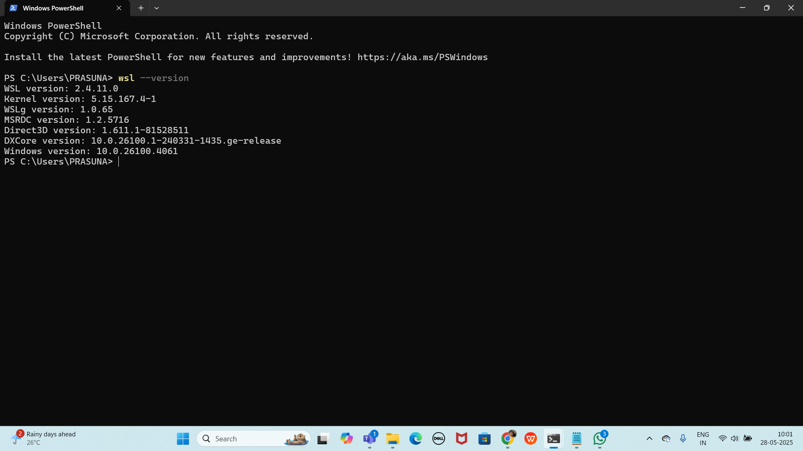

If not installed try to use below linux..

In cmd:

wsl

Install linux

<https://learn.microsoft.com/en-us/linux/install>

Task 1:

Create a Directory with the Name Linux Practice.

Hint: use mkdir LinuxPractice

3 min

Task2:

Change to the directory

Hint: use cd .\LinuxPractice\

2 min

Task 3:

Create a file name TestFile1.txt and add the content to it.

5 min

Task 4:

Create a Folder named Dummy and try to delete it.

5 min.

Task 5:

Plz check the working directory (Hint : pwd)

2 min

Task 6:

How do you check all the files and directories in the directory you are in?

3 min

Task 7:

Create five files named TestFile2.txt.. TestFile3.txt… and so on till TestFile6.txt

5min

Task 8:

Copy all files from Dir 1 ti Dir 2

2 min

Task 9:

Move all files from Dir 2 to Dir 3 (finally ur Dir 2 should be empty)

3 min

Task 10:

Can you plz show me the diff between **rm** and **rmdir** commands with screen shots ?

5 min

Ok now open Lorem Ipsum in your browser

<https://www.lipsum.com/> u can use this link for random text..

Task 11:

Now use specifically use cat command to create a file

And add the dummy text of 2 to 3 paragraphs from the above link Lorem Ipsum.

5 min

Task 12:

How to get only the top part of your file..

Hint: use head

5 min

Task 13:

How to get only the last part of your file

Hint: use tail

5 min

Task 14:

Plz add dummy text of 5 to 6 pages in to the same file

And

Now show the file in page by page

Hint : use less command

10 min

Task 15:

Use more command on the above file and find out the diff between less command and more command.

5 min

What is e in echo command..?

The e in the echo command is an option that enables the interpretation of backslash escape sequences. These sequences allow you to insert special characters and formatting into the output.

Task 16:

Can you use echo command with -e and see the diff.. Also take a ss and paste .

4 min

Task 17:

What is diff between ls and ls -l command .. ss plz

5 min

Task 18:

Create a file using **touch** command , **cat** command and **echo** command and take ss (screen shot)..

Also write the difference between touch , cat and echo commands.

5 min

Task 19:

Can you guys try to display the calendar by using a command..

Hint: use cal

2 min

Task 20:

Can you go back to 1 directory .. at a time whats the command

2 min

Task 21:

How to know whose user u are working on ?

Hint: use whoami command

2 min

Task 22:

Try to find out who is peeping into your system..

Hint: Use users, who and w commands with ss

10 min

Task 23:

Can you guys try to check how much disk space is consumed..

Hint : use df -h

Task 24:

In the **ls -l** listing example, every file line begins with a **d**, **-**, or **l**. These characters indicate the type of the file that's listed.

Can you plz try using the below commands

| **Prefix** | **Description** |
| --- | --- |
| **-** | **Regular file**, such as an ASCII text file, binary executable, or hard link. |
| **b** | **Block special file**. Block input/output device file such as a physical hard drive. |
| **c** | **Character special file**. Raw input/output device file such as a physical hard drive. |
| **d** | **Directory** which contains a listing of other files and directories. |
| **l** | **Symbolic link file**. Links on any regular file. |
| **p** | **Named pipe**. A mechanism for interprocess communications. |
| **s** | **Socket** which is used for interprocess communication. |

Task 25:

Find the list pf all files ending with .txt

Hint : use * in ls

2 min

Task 26:

In Linux all the hidden files starts with . (period)

How to check all the hidden files in Linux..

Hint : use ls -a

Task 27:

What is the difference between . and .. in linux

Line 1 line for each

2 min 15.38 to 15.40

Task 28:

Can you create a file using vi editor and show the details in ss

Hint:

Esc is for come out of the edit mode

Press two keys Shift &plus; ZZ together to come out of the file completely

* I - to insert

To move inside the file

* **l** key to move to the right side.
* **h** key to move to the left side.
* **k** key to move upside in the file.
* **j** key to move downside in the file.

Task 29:

How to find the no of words in the file

Hint: use wc

15.44 to 15.48

Here is the detail of all the four columns of wc command −

* **First Column** − Represents the total number of lines in the file.
* **Second Column** − Represents the total number of words in the file.
* **Third Column** − Represents the total number of bytes in the file. This is the actual size of the file.
* **Fourth Column** − Represents the file name.

Task 30:

What is the use of cat -b myfilename.txt command?

15.49 tpo 15.52

Task 31:

Can I use the wc with 2 or more files?

Wc file1 file2 file3

15.53 to 15.58

Task 32:

How to copy content of one file to another file

Hint: use cp:

15.59 to 16.05

Task 33:

Now I want to rename my file with MYFILENEW can i do that if so how ?

Hint use : mv

Task 34:

Can i remove or delete multiple files in linux..? How?

16.06 to 16.08

Task 35:

In directory / slash is root … can you try cd / what is it doing?

Ss plz

16.09 to 16.11

Linux directory structure: plz have a reading and try to remember..

| **Directory** | **Description** |
| --- | --- |
| **/bin** | important binary applications |
| **/boot** | boot configuration files, kernels, and other files needed at boot time. |
| **/dev** | System device files. |
| **/etc** | configuration files, startup scripts, etc. |
| **/home** | List of home directories for different users |
| **/lib** | system libraries, shared libraries |
| **/lost+found** | a lost+found system for files that exist under the root (/) directory |
| **/media** | automatically mounted (loaded) partitions on your hard drive and removable media such as CDs, digital cameras, etc. |
| **/mnt** | manually mounted filesystems on your hard drive |
| **/opt** | 3rd part applications to be installed |
| **/proc** | Maintains information about the state of the system, including currently running processes. |
| **/root** | root user's home directory. |
| **/sbin** | important system binaries |
| **/srv** | contain files that are served to other systems |
| **/sys** | system files |
| **/tmp** | temporary files |
| **/usr** | applications and files that are mostly available for all users to access |
| **/var** | variable files such as logs and databases |

Task 36:

What is the way go go to home directory ?

Hint : use cd ~

16.12 to 16.15

16.15 to 16.30 Tea Break

Task 37:

If i want to move to different users home directory

Hint : use ~username

16.30 to 16.35

Task 38:

Chmods:

Doc 11 Linux intro.pdf shared in docs to study folder in the shared drive..for your ref..

Cat /etc/passwd — for displaying users in wsl

awk -F':' '{ print $1}' /etc/passwd → only displays user names

To come out of the editor

Esq : wq enter

In power shell

To clear the entire screen

Clear

History you can see by typing History command

In powershell

To create file

Cat command:

